Manual Return
If there's no Internet, you can manually return the license in offline mode.

STEPS:
- Click Manual Return on the Return ZWCAD 2018 License page to display the prompt drop-down page, and then enter the Current License Code.
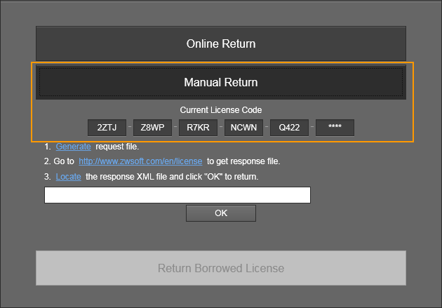
- Click Generate text link according to the prompt and specify a path that you want to save the return request file in the pop-up Save as dialog box.
- Login http://www.zwsoft.com/en/license to obtain a response file.
STEPS:
- Fill in the blank with your activation ID and personal information. Then click Submit.
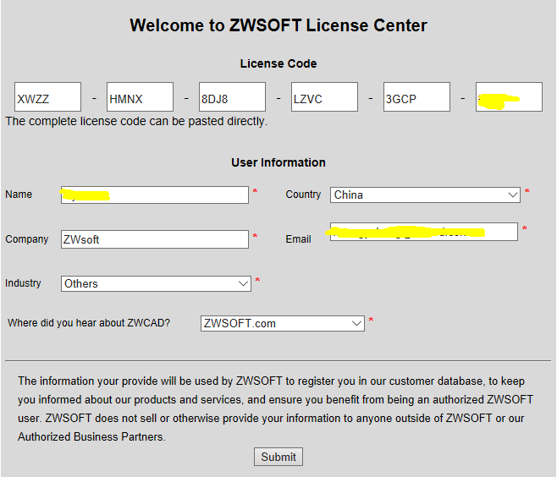
- Select the Manage Licenses tabs.
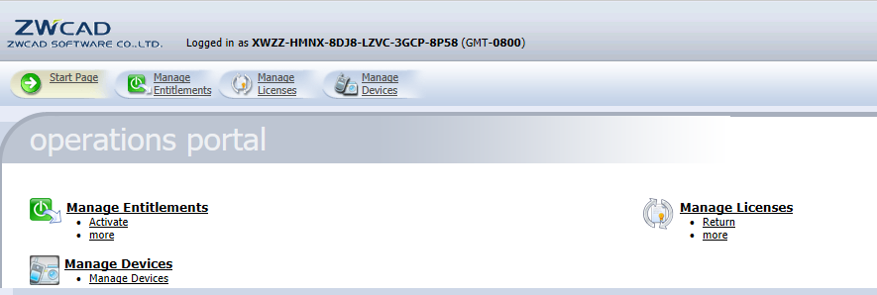
- Check the product and click Manual Return.
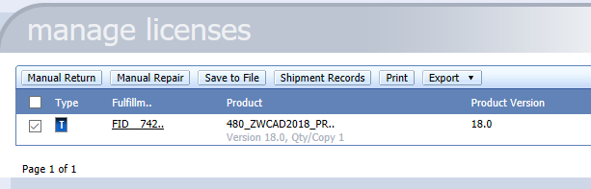
- Click Browse to import the activation request file generated on step 2, and then click Submit.
- Display the Activation ID information, save your response file by clicking Save To File, and then exit the ZWCAD Self-Service Activation Platform.
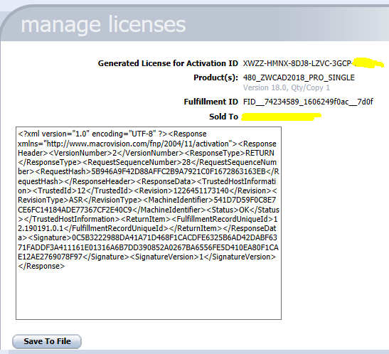
- Click Locate text link according to the prompt, import your response file obtained on Step 2 in the Locate Response XML File dialog box, and then click OK.
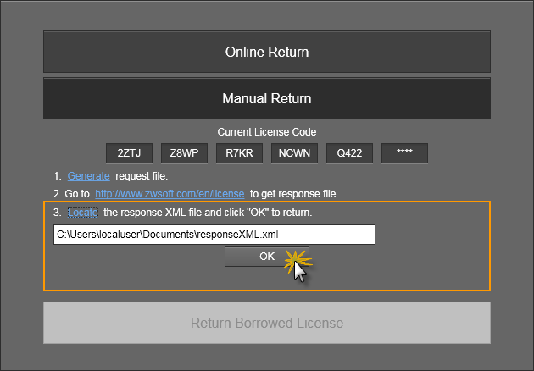
- If you click OK in the following dialog box, the license will be successfully returned.
